**Q_01.**

Code:

package Q_01;  
import javax.swing.*;  
  
  
public class Q1{  
 public static void main(String[] args){  
 JFrame welcomeFrame;  
 welcomeFrame=new JFrame();  
 welcomeFrame.setSize(800,600);  
 welcomeFrame.setTitle("Welcome to Java");  
 welcomeFrame.setVisible(true);  
 }  
}

Output:

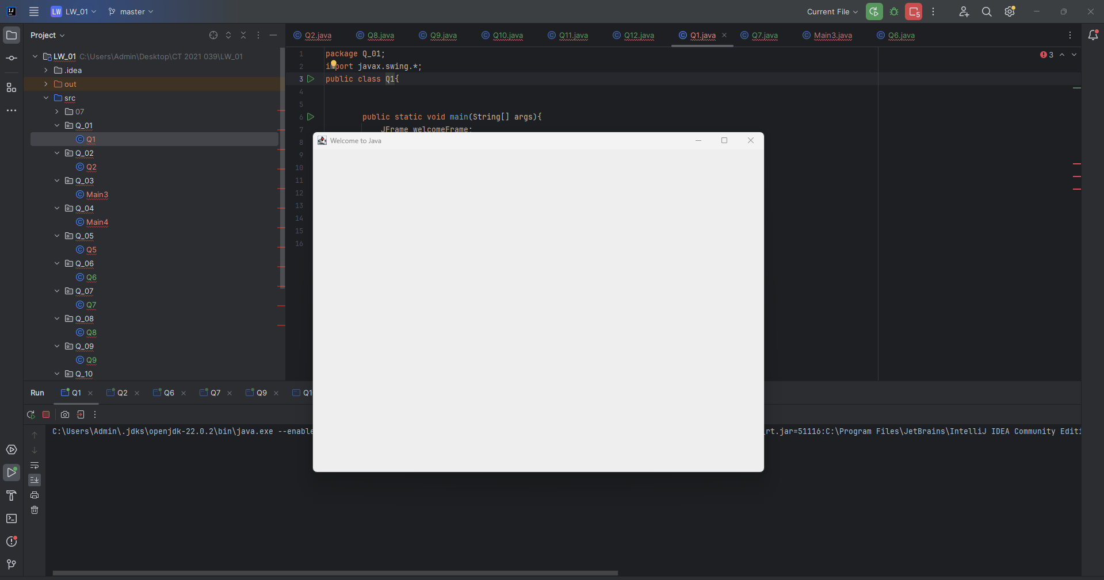

**Q_02.**

Code:

package Q_02;  
  
import javax.swing.*;  
import java.util.Scanner;  
  
  
public class Q2 {  
 public static void main(String[] args){  
 Scanner input =new Scanner(System.*in*);  
  
 System.*out*.print("Enter first name");  
 String firstName=input.next();  
  
 System.*out*.print("Enter last name");  
 String lastName=input.next();  
  
 input.close();  
  
 JFrame welcomeFrame;  
 welcomeFrame=new JFrame();  
 welcomeFrame.setSize(800,600);  
 welcomeFrame.setTitle(firstName+" "+lastName);  
 welcomeFrame.setVisible(true);  
  
 }  
  
}

Output:

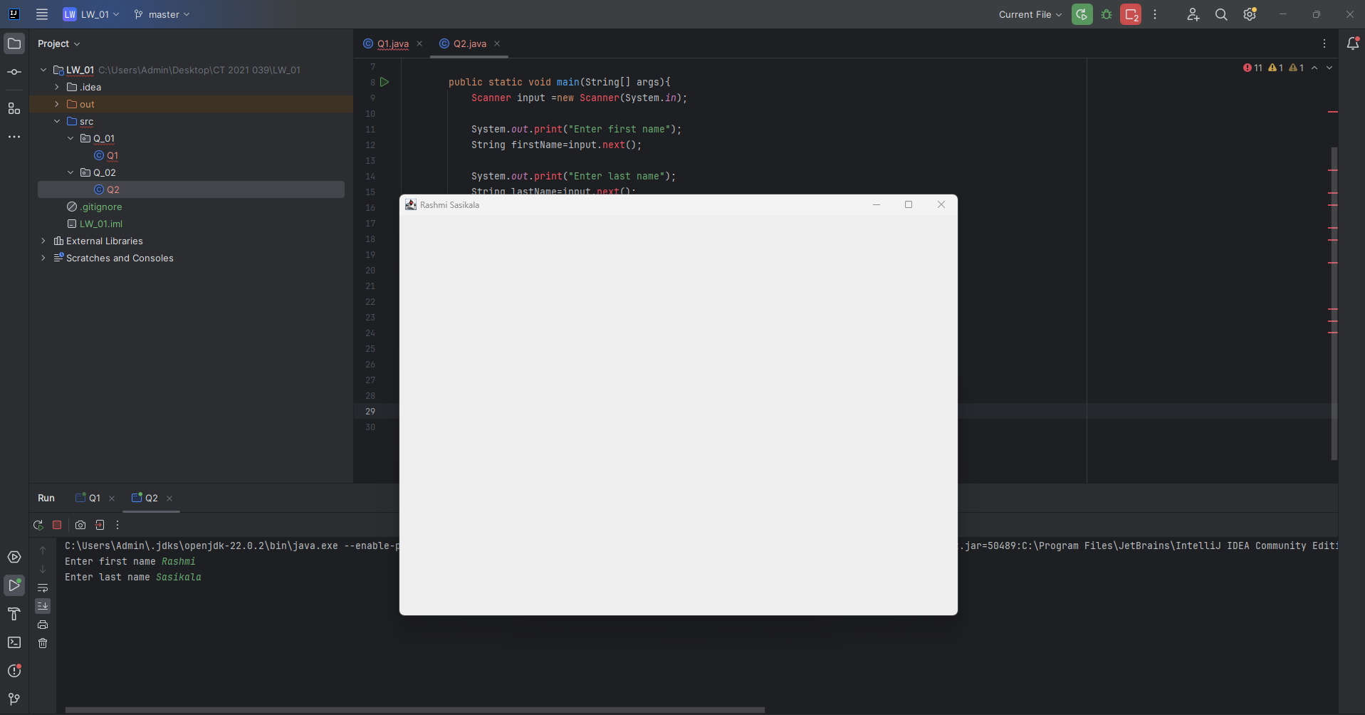

**Q_03.**

Code:

package Q_03;  
  
import javax.swing.*;  
import java.util.Scanner;  
  
public class Main3 {  
 public static void main(String[] args) {  
 Scanner input = new Scanner(System.*in*);  
  
 System.*out*.print("Enter first name");  
 String firstName = input.next();  
  
 System.*out*.print("Enter middle name");  
 String middleName = input.next();  
  
 System.*out*.print("Enter last name");  
 String lastName = input.next();  
  
 String midInitial = middleName.substring(0, 1) + ".";  
  
 input.close();  
  
 System.*out*.println("Formatted Name:" + firstName + " " + midInitial + lastName + ".");  
 }  
}

Output:

**Q_04.**

Code:

package Q_04;  
  
import java.util.Date;  
import java.text.SimpleDateFormat;  
  
public class Main4 {  
 public static void main(String[] args){  
 Date today=new Date();  
  
 SimpleDateFormat dateFormat = new SimpleDateFormat("d MM yyyy");  
  
 String formattedate = dateFormat.format(today);  
  
 System.*out*.println("Today's date is:"+formattedate);  
  
  
 }  
}

Output:

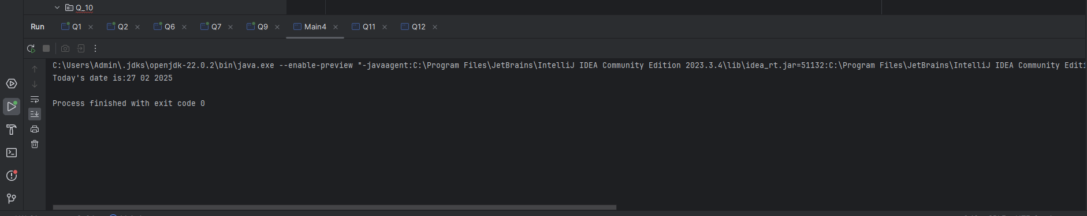

**Q_05.**

Code:

package Q_05;  
import java.text.SimpleDateFormat;  
import java.util.Date;  
public class Q5 {  
 public static void main(String[] args){  
 Date today=new Date();  
 SimpleDateFormat dateFormat = new SimpleDateFormat("EEEE,MMMM d,yyyy");  
 String formattedDate=dateFormat.format(today);  
 System.*out*.println("Today's date is:"+ formattedDate);  
 }  
}

Output:

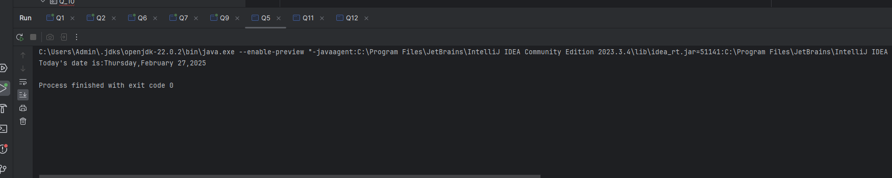

**Q_06.**

Code:

package Q_06;  
  
import javax.swing.*;  
import java.util.Scanner;  
public class Q6 {  
 public static void main(String[] args){  
 Scanner scanner=new Scanner(System.*in*);  
  
 System.*out*.print("Enter the width of the window:");  
 int width=scanner.nextInt();  
  
 System.*out*.print("Enter the height of the window:");  
 int height=scanner.nextInt();  
  
 scanner.nextLine();  
  
 System.*out*.print("Enter the title of the window:");  
 String title=scanner.nextLine();  
  
  
 JFrame frame=new JFrame(title);  
 frame.setSize(width,height);  
 frame.setDefaultCloseOperation(JFrame.*EXIT_ON_CLOSE*);  
 frame.setVisible(true);  
  
 scanner.close();  
  
 }  
}

Output:

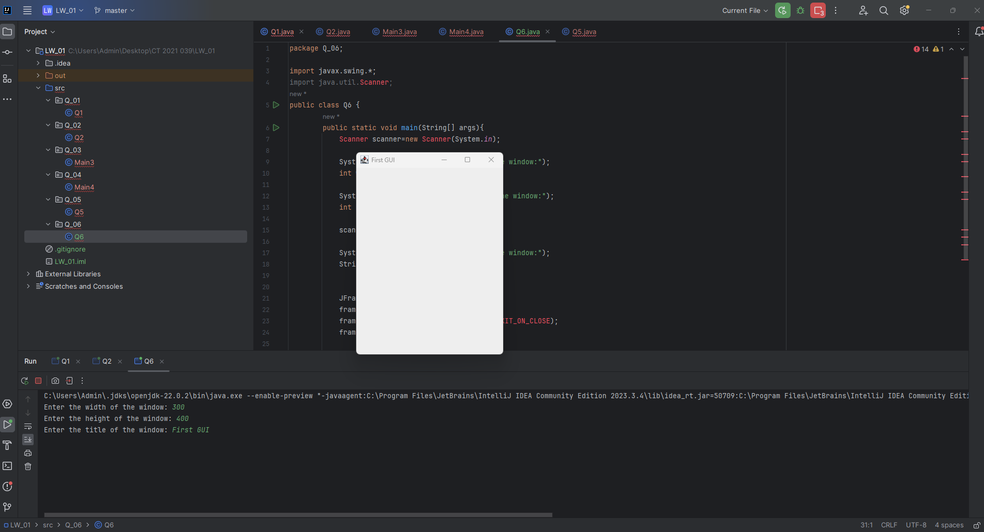

**Q_07.**

Code:

package Q_07;  
  
import javax.swing.*;  
import java.text.SimpleDateFormat;  
import java.util.Date;  
  
  
public class Q7 {  
 public static void main(String[] args){  
 JFrame frame=new JFrame();  
  
 frame.setSize(800,600);  
  
 frame.setDefaultCloseOperation(JFrame.*EXIT_ON_CLOSE*);  
 Timer timer=new Timer(1000,e -> {  
 String currentTime=new SimpleDateFormat("hh:mm:ss a").format(new Date());  
 frame.setTitle(currentTime);  
 } );  
 timer.start();  
 frame.setVisible(true);  
  
 }  
}

Output:

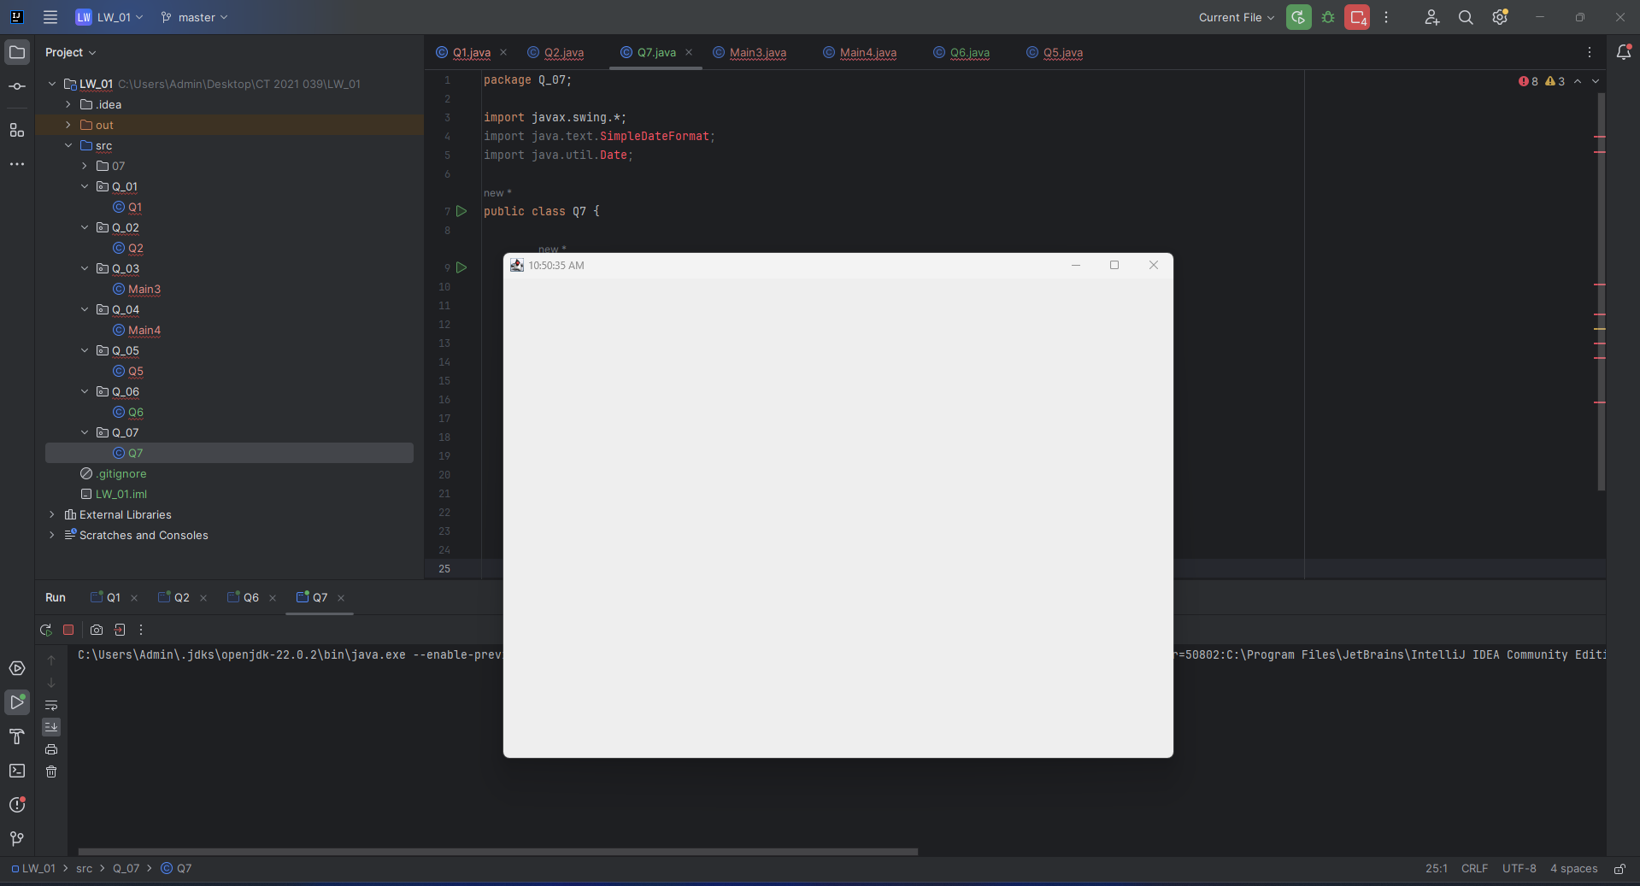

**Q_08.**

Code:

package Q_08;  
  
import java.util.Scanner;  
public class Q8 {  
  
  
  
 public static void main(String[] args) {  
  
 Scanner scanner = new Scanner(System.*in*);  
  
 System.*out*.println("Enter a string with an exclamation mark (!):");  
 String input = scanner.nextLine();  
  
 int exclamationIndex = input.indexOf('!');  
  
  
 if (exclamationIndex != -1) {  
  
 String beforeExclamation = input.substring(0, exclamationIndex).trim();  
  
 String afterExclamation = input.substring(exclamationIndex + 1).trim();  
  
 System.*out*.println(beforeExclamation);  
 System.*out*.println(afterExclamation);  
 } else {  
  
 System.*out*.println("No exclamation mark found in the input string.");  
 }  
  
  
 scanner.close();  
 }  
}

Output:

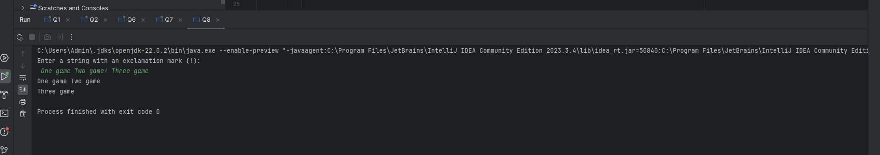

**Q_09.**

Code:

package Q_09;  
  
import java.util.Scanner;  
public class Q9 {  
  
  
 public static void main(String[] args) {  
  
 Scanner scanner = new Scanner(System.*in*);  
  
 System.*out*.println("Enter a string:");  
 String input = scanner.nextLine();  
  
 if (input.length() > 0) {  
  
 System.*out*.println(input.length());  
  
 System.*out*.println(input.charAt(0));  
  
 System.*out*.println(input.charAt(input.length() - 1));  
 } else {  
  
 System.*out*.println("The string is empty.");  
 }  
  
 scanner.close();  
 }  
}

Output:

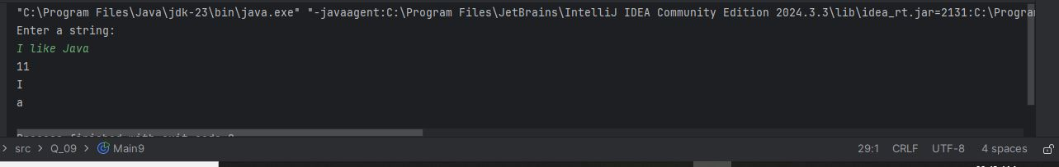

**Q_10.**

Code:

package Q_10;  
  
import java.util.Scanner;  
  
public class Q10 {  
  
  
 public static void main(String[] args) {  
  
 Scanner scanner = new Scanner(System.*in*);  
  
 System.*out*.println("Enter an odd-length word:");  
 String input = scanner.nextLine();  
  
 if (input.length() % 2 != 0) {  
  
 int middleIndex = input.length() / 2;  
  
 System.*out*.println("The middle character is: " + input.charAt(middleIndex));  
 } else {  
  
 System.*out*.println("Please enter a word with an odd number of characters.");  
 }  
  
 scanner.close();  
 }  
}

Output:

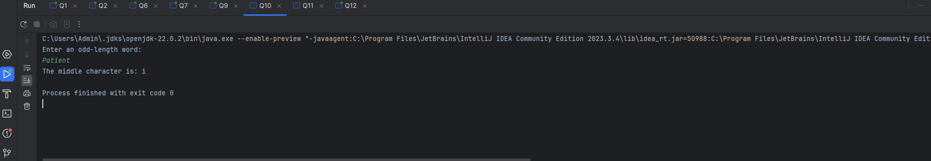

**Q_11.**

Code:

package Q_11;  
  
import java.util.Scanner;  
  
public class Q11 {  
  
 public static void main(String[] args) {  
  
 Scanner scanner = new Scanner(System.*in*);  
  
 System.*out*.println("Enter your full name (first middle last):");  
 String fullName = scanner.nextLine();  
  
 String[] nameParts = fullName.split(" ");  
  
 if (nameParts.length == 3) {  
  
 String firstName = nameParts[0];  
 String middleName = nameParts[1];  
 String lastName = nameParts[2];  
  
 String middleInitial = middleName.substring(0, 1).toUpperCase() + ".";  
  
  
 System.*out*.println(lastName + ", " + firstName + " " + middleInitial);  
 } else {  
  
 System.*out*.println("Please enter your full name in the format: first middle last.");  
 }  
  
  
 scanner.close();  
 }  
}

Output:

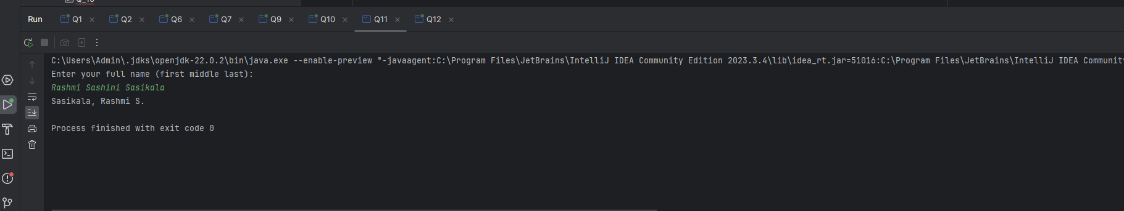

**Q_12.**

Code:

package Q_12;  
  
import javax.swing.JFrame;  
  
public class Main12 {  
  
 public static void main(String[] args) {  
  
 JFrame frame = new JFrame();  
  
 frame.setTitle("My First Frame");  
  
 frame.setSize(300, 200);  
  
 frame.setLocation(100, 50);  
  
 frame.setDefaultCloseOperation(JFrame.*EXIT_ON_CLOSE*);  
  
 frame.setVisible(true);  
 }  
}

Output:

